**Instruction for writing project Report:**

1. Font type (Times New Roman) size 12 must be same as in this report.
2. Index for figures and tables must be separate as given in project.
3. If figure or table comes in chapter one then title will be Figure 1.1, Figure1.2, ... so on and Table 1.1, Table 2.1,..so on. For chapter two Figure 2.1, Figure 2.2,…and Table 2.1, Table 2.2,…. and so on.
4. Normal Text of font Size 12 in Times New Roman font style, not bold and **justify** format(Ctrl z).
5. Chapter number and name with font size 18 in Times New Roman font style (Bold letters, each letter is in Uppercase, aligned to centre).
6. Main Heading of chapters are with font size 16 in Times New Roman font style (Bold letters, each letter is in Uppercase and justify format (Ctrl z)).
7. Sub heading of chapters are with font size 14 in Times New Roman font style (without Bold, each word is in sentence case and justify format (Ctrl z)).
8. Code of project must be added as part of appendix.
9. Snapshot must be taken from running project.

**TOPIC**

*Submitted by*

**NAME1**

**NAME2**

**Under the guidance of**

*Mr. XYZ*

*DESIGNATION*

**GEHU LOGO**

**DEPARTMENT OF COMPUTER SCIENCE AND ENGINEERING**

**GRAPHIC ERA HILL UNIVERSITY**

**Date**

**CERTIFICATE**

This is to certify that the thesis titled **“Title of PROJECT” submitted** by **Author**, to Graphic Era Hill University for the award of the degree of **Bachelor**  **of Technology**, is a bona fide record of the research work done by him/her under our supervision. The contents of this project in full or in parts have not been submitted to any other Institute or University for the award of any degree or diploma.

**Name of guide**  Project Guide

(Designation)

GEHU,Dehradun

Place: Dehradun

Date:

**ACKNOWLEDGEMENT**

Thanks to Mr. Bill Gates for creating Microsoft Word and with it an easy-to-use word processor. Use your own language.

**Name of student 1 Name of student 2**

Roll no. Roll no.

**ABSTRACT**

A simple template is provided here in MS Word class. This can be used to easily write a thesis suitable for submission at GEHU. The class provides options for B.Tech.

The formatting is (to the best of knowledge of the authors) as per the guidelines of the institute.

**TABLE OF CONTENTS**

**ACKNOWLEDGEMENT i**

**ABSTRACT ii**

**LIST OF TABLES iv**

**LIST OF FIGURES v**

**ABBREVIATIONS vi**

**NOTATIONS vii**

# INTRODUCTION 1

## MS Word features………………………………….……………….................... 2

## MS Word figures……………………………………………………………….. 2

## MS Word options………………………………………………………………. . 2

# REQUIREMENT ANALYSIS

2.1----

# A SAMPLE APPENDIX 3

**LIST OF TABLES**

## A sample table with table caption placed appropriately. This caption is very long and is single-spaced. Notice how the text is aligned……..…………….4

**LIST OF FIGURES**

## A sample figure with figure title placed appropriately. This title is very long and is single-spaced. Notice how the text is aligned……..…………….4

**ABBREVIATIONS**

GEHU Graphic Era Hill University

MWW Microsoft Word is Wonderful

**NOTATIONS**

*α* Scale parameter

*β* Depth angle in degrees

# CHAPTER 1

(SAME FORMAT FOR OTHER CHAPTER)

# INTRODUCTION

# (OR ANY OTHER HEADING)

This is the first chapter of the thesis/dissertation template. This is to indicate the formatting style of the report. The line spacing is 1.5, with the indent at the new paragraph.

The new paragraph can start in the next line, with no gap. There is an indentation of 0.2” at the beginning of the paragraph. Paragraph in the thesis will always be justified, not left-centered.

## **MS Word features**

A new section paragraph starts with no indentation. However, there will be a regular indentation of 0.2” at the start of next paragraph.

If we want to insert a figure in the text, it has to be centered and suitable title be added for the same. For example,

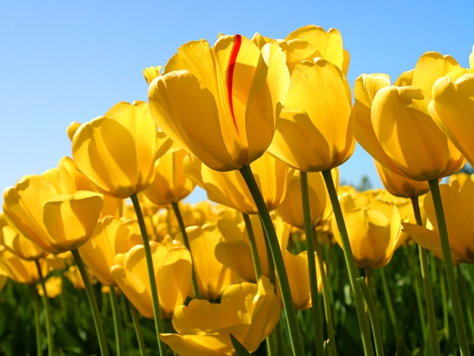

# CHAPTER 2

# Requirement analysis

# (SRS should be included in this chapter ie use case, DFD, Class Diagram ,ER diagram etc)

The new paragraph can start in the next line, with no gap. There is an indentation of 0.2” at the beginning of the paragraph. Paragraph in the thesis will always be justified, not left-centered.

## **MS Word features**

A new section paragraph starts with no indentation. However, there will be a regular indentation of 0.2” at the start of next paragraph.

If we want to insert a figure in the text, it has to be centered and suitable title be added for the same. For example,



Figure 1.1:

A sample figure with figure title placed appropriately. This title is very long  
 and is single-spaced. Notice how the text is aligned.

Table 1.1: A sample table with caption placed appropriately. This title is very long  
 and is single-spaced. Notice how the text is aligned.

|  |  |  |  |  |
| --- | --- | --- | --- | --- |
| x | 0 | 2 | 5 | 7 |
| f(x) = x2 | 0 | 4 | 25 | 49 |

## **MS Word figures**

How does one itemize bullets in a thesis? Well, this is how:

* First bullet.
* Second bullet is to be inserted like this. This bullet is being inserted just to demonstrate the paragraph features in the “itemize” environment. “Itemize” is a standard name of the “Bullet” format if you are using LaTeX word editor.
* Third simple bullet.

Similarly, we can write the other chapters.

# CHAPTER 3

# softwrae / project design

# ( Algo and blue print should be included in this chapter with proper diagram)

The new paragraph can start in the next line, with no gap. There is an indentation of 0.2” at the beginning of the paragraph. Paragraph in the thesis will always be justified, not left-centered.

## **MS Word features**

A new section paragraph starts with no inde

# CHAPTER 4

# Result/TESTING OF PROJECT / SOFTWARE

TEST CASES WITH WHITE AND BLACK BOX TESTING ETC

The new paragraph can start in the next line, with no gap. There is an indentation of 0.2” at the beginning of the paragraph. Paragraph in the thesis will always be justified, not left-centered.

# CHAPTER 5

# Conclusion AND fUTURE SCOpe

The new paragraph can start in the next line, with no gap. There is an indentation of 0.2” at the beginning of the paragraph. Paragraph in the thesis will always be justified, not left-centered.

**APPENDIX A**

**(Code)**

It will contain code of project/software.

**References**

[1] Ji, XunSheng, et al. "Application of the digital signal procession in the MEMS gyroscope de-drift." *Nano/Micro Engineered and Molecular Systems, 2006. NEMS'06. 1st IEEE International Conference on*. IEEE, 2006.

[2] Nussbaumer, Henri J., and Martin Vetterli. "Computationally efficient QMF filter banks." *Acoustics, Speech, and Signal Processing, IEEE International Conference on ICASSP'84.*. Vol. 9. IEEE, 1984.

Sites those you used

Any other reference

**Publications**

**(if any)**

[1] Ji, XunSheng, et al. "Application of the digital signal procession in the MEMS gyroscope de-drift." *Nano/Micro Engineered and Molecular Systems, 2006. NEMS'06. 1st IEEE International Conference on*. IEEE, 2006.